

**Irakli Lomidze**

**G00275525**

B.Sc. (Hons) in Software Development

Hiking Ireland Application Developed With Ionic 5



**Final Year Project**

Supervised by: Dr. Dominic Carr

Department of Computer Science and Applied Physics Galway-Mayo Institute of Technology (GMIT)

**Acknowledgement**

I'd want to express my gratitude to all of my professors throughout the years, as well as to my supervisor, for his guidance and for guiding me in the correct path during the year. Finally, I'd want to express my gratitude to my class fellows for motivating me.

In the last, it goes to my friends who have assisted me with my inquiry and who have provided me with thoughts and ideas to carry out the duties given to me for my final year project, my heartfelt appreciation and gratitude will be directed their ways.

Abstract

The term “Tourism” is defined as group or individual travelling in the places which are outside of their usual environment. The area of tourism has diversified a lot in the past few years. It has become one of the rapidly growing economic sectors. In the world this sector has even out rank other sectors such as automobile, oil experts and food products. The sector of tourism has become the primary player in the international commerce sector. This motivates me to develop an application which helps in promoting this sector. This application offers services to tourists make their outdoor activities experience better and also enhance their experience of hiking with the correct available information just at the tip of their fingers. The objective of this gap is to full fill the above-mentioned gap by implementing a web base application for hiking. The scope of this application is both external and internal tourists involve in hiking activity in Ireland. Users may plan their next trip and add it to the list using this application, which allows them to input data and have it stored. Users may locate places and save visits using the Google maps feature, which is also available in this Application. A client and a server, both of which retrieve data from databases, have been developed for this application.

Table of Contents

1 Chapter 1: Introduction 8

1.1 Objectives 8

1.2 Core Pages of Application: 9

1.3 Personalized Features 9

1.4 Chapter Description 10

1.5 Project Links 10

1.6 Chapters Review 10

2 Chapter 2: Literature Review 11

3 Chapter 3: Methodology 13

3.1 Approaching the problem 13

3.2 Version Control 14

3.3 Testing 15

3.3.1 White Box Software Testing Technique 15

3.3.2 Black Box Software Testing Technique 15

3.4 Development Timeline & Tasks 15

3.4.1 Creating Pages 16

3.4.2 Menu Navigations 16

3.4.3 Registration and login 16

3.4.4 Back End 16

3.4.5 Home page 16

3.4.6 Google Maps API 17

3.4.7 Settings 17

3.4.8 Adding Extra Features 17

3.4.9 Favorites 17

3.4.10 Record and Places 17

4 Chapter 4: Technology Review 18

4.1 Presentation 18

4.1.1 Ionic 18

4.1.2 Ionic User Interface 18

4.1.1 Cordova 19

4.1.3 Angular 20

4.2 Logic 21

4.2.1 NodeJS 21

4.2.2 npm 22

4.3 Data Section 22

4.3.1 Firebase 22

4.4 Additional 23

4.4.1 Google Maps API 23

4.4.2 Typescript 24

4.4.3 HTML 25

4.4.4 SCSS 25

4.4.5 JavaScript 26

4.5 Software and tools used 26

4.5.1 Visual Studio Code 27

4.5.2 GitHub 27

4.5.3 Microsoft Word 29

5 Chapter 5: System Design 29

5.1 Data 30

5.1.1 Firebase Authentication 30

5.1.2 Firebase real time Database 30

5.1.3 Firestore 31

5.2 Logic 32

5.2.1 Connection to Data 32

5.2.2 Routing and accessing data 33

5.2.3 Connecting to Presentation 35

5.3 Presentation 35

5.3.1 Ionic 5 Application Structure 36

5.4 6 Pages at Application 36

5.4.1 Login Page 37

5.4.2 Register Page 38

5.4.3 Menu Bar 38

5.4.4 Home Page 39

5.4.5 Record Page 39

5.4.6 Places Page 40

5.4.7 Capture Page 40

5.4.8 Setting Page 41

5.4.9 Personalized Page 42

5.4.10 General Features Page 43

5.4.11 Deployment and Hosting 45

6 Chapter 6: System Evaluation 45

6.1 7.1 Robustness 46

6.2 Testing 46

6.3 Ionic Serve 46

6.3.1 Device Testing 46

6.4 Limitations 47

6.4.1 Service Limitations 47

6.4.2 Testing on Apple device 47

6.5 Results & Objectives 47

7 Chapter 7: Conclusion 48

7.1 Future Development 49

7.1.1 App Development 49

8 References 50

9 Important Links 54

10 Chapter 8: Appendix 55

10.1 Project Source Code Link: 55

# Chapter 1: Introduction

Hiking is refer as a long-distance walk, particularly a cross-country excursion. It is included in the category of outdoor recreation and activities since it is a leisure activity that takes place in the great outdoors, particularly in a natural environment away from the city limits. Hiking is a goal-directed outdoor activity that is physically, mentally, emotionally, and spiritually gratifying. It is a rewarding activity on all levels. It will undoubtedly put to the test the individual's will to succeed via endurance, stamina, and survival abilities (Benxia, Mei, Hou, & Qiu, 2021).

In the last several years, there has been a significant shift in the tourist industry. It has developed into one of the most quickly expanding economic sectors. This industry has surpassed other industries across the globe, including the automotive industry, oil specialists, and food goods. The tourist industry has risen to become the most important participant in the world's international trade sector. This has inspired me to create an application that will aid in the promotion of this industry. This application provides services to tourists to make their outdoor activities more enjoyable and to enhance their hiking experience by providing them with the most up-to-date information available at the touch of a button on their smartphones (Havatzelet, Cavari, & Galilee, 2021).

It was important to me while selecting this project that I was developing something that could contribute in the economy of the country. I wanted a project that demonstrates my abilities that I had gained over the course of four years as a student, as well as the ability to build on those skills by adding new talents that would aid in my overall growth as a software engineer. When I was thinking about what application I wanted to create, I came up with the idea for Hiking Ireland (Daniel, Hall, Costa, & Bradford, 2021). As the name indicates, the majority of the program's primary components would be focused on outdoor activities, which is exactly what I wanted to accomplish. The general context of this application revolves around people who love outdoor Hiking activities. Users of this application will be able to keep track on their hiking trips, store information about trips, record location, search places and display information, capture multimedia and change user settings this are core application features.

* Home
* Record
* Places
* Capture
* Settings

## Objectives

The primary objective of this study is to develop a web-based application which provide critical and relevant information regarding the hiking activities in Ireland. The application is easy to use by the users.

The aim of the project is to meet the following objectives:

1. Compile all of the pertinent information about hiking destinations in Ireland, including contact information for the appropriate authorities.
2. Research and evaluate the requirements for creating an web-based application to meet the demands of hikers who want to go to a certain hiking location in Ireland.
3. Objectives 1 and 2 are included into the design and development of the web application.
4. Validate and test the application that was built in accordance with goal 3.

## Core Pages of Application:

The following is the list of core pages in this application and their main functions:

* + - **Login/Create account page -** A login and a registration page are available in the application. The login page allows users to safely log into the application, while the register page allows users to register with application. The user has access to additional functionality that are not available to unregistered users until signed in.
    - **Home page –** Home page is base for navigation for the application, when successfully logged in home page will display users list of trips.
      * When user clicks on ad icon user will be directed to from where user can add name, select start and end locations from google maps after this is done user will be shown distance between two locations.
    - **Record –** Function of this page is to record your desired location and save it in database (Ngoc, 2021).
    - **Capture –** Function of this page is that user can compute multimedia and upload.
    - **Settings –** Function of this page is that user can edit user details or log out from the application.

## Personalized Features

* The following is the list of Personalized Features that app comes with:
* **Upload –** Function of this page is that user can upload pictures from their devise.
* **My Favorites –** Function of this page is for users to see their favorite places that they have added to ‘Favorites’ list.
* **Trip History –** Function of this page is to display trips they have saved, user can view saved trips.
* **Calories Calculator –** This feature was added as an extra feature for the app, user can feel in the form and their calories will be calculated.

The following is the list of General Features that app comes with.

1. **Login –** Page for user to login in the application.
2. **Register –** Page for user to register in the application**.**
3. **News/Events –** Page for user to see up to date news.
4. **Covid-19 –** Page for user to see up to date COVID-19 case informationn
5. **Home –** Page for user to return on main home page.

## Chapter Description

**Methodology -** Methodology discusses the project's scope, its goal, and any other ideas thatt were considered. Along with development methodology used for project's development approach, its time management and the initial setup for verification and testing.

**Technology Review -** The Technology Review discusses the technologies researched and implemented into the project. Along with describing how they meet the requirements of the project.

**System Design -** System Design goes through the entire design of the project and how it was allconstructed together to become a final product.

**System Evaluation -** System Evaluation tells how the final product was thoroughly tested throughout the front-end and back-end. Including a section for issues encountered that caused long pauses in development

**Conclusion** - The Conclusion summaries the project, possible next steps for it, what was learned from the project and addresses the objectives outlined in the introduction.

## Project Links

Repository Link:<https://github.com/ika25/hikingapp2.0>

## Chapters Review

This paper is divided into chapters that cover anything from project preparation to solution design and implementation. The following subsections will give you a quick summary of each chapter in the project.

***Methodology Used:*** In this chapter, researcher will go through some of the methodologies that are used in the development of the application. Agile, version control and testing will all be covered in this section.

***Technology Review:*** In the Technology Review, a few technologies will be reviewed that will helped in development of this application, this includes front end and back end technologies and development tools.

***System Design:*** researcher will go over the system architecture and functionality of this application in depth in System Design. I will go into why these innovations were chosen and how they were incorporated into the device design

***System Progression and Evolution:*** The robustness, testing, Results V Objectives, and limits of the system will be evaluated in this chapter.

***Project Conclusion:*** In the end, researcher will summarize the project in terms of its aims and objectives. The application will be reviewed, and potential future progress will be discussed.

# Chapter 2: Literature Review

Fabian & Peters (2020) stated that adventure activities become core products of tourism destinations. Hkiking is considered as the adventure activity that presents many different products relevant to field. Research effectivley explored hikers experiences and motivations. To conduct this research quantitative method is chosen, results provides SAM factors and focus that socilizing,l discivery and relaxation are the factors that are connected with hiking. This paper effectively adds understanding of SAM in the context of hiking, helps in connecting the missing link to previous outdoor leisure studies (Fabian & Peters, 2020).

According to Belén (2019) discussed about the hiking activites that are involved in the process, important regional variations and hiking is linked with clubs. New agents are involved in the ways in processes of territoral planning that impact on national, regional and local administration. This article effectively transform change in territoral model for management. Adoption of accomidation and the restaurant facilities or services connected with it can emerg the angagment of new stakeholders in the planning and communicatuon of the hiking related activities. Maturity of this activity is evident from the hiking numbers as the products are nore availabe on the tourism market however in past there was only the few selection tracks (Belén, 2019).

Josep et al. (2018) stated that nature-based toruism is getting more common in the people. Hiking activity may create benefits for the host community as well and provide numerous opporunities to have good time. Cost benefit analysis is employed in this article to contribute in knowledge relevant to the areas by esitmating economic and social impacts. This also define the tangible and non-tangible aspects impacting hiking activities during tour. Data collection between in a timespan of one year, shows quite a positive return on the society and it enable the polocy makers to assess value of resist additonal torusim development (Josep, Garcia, & Celma, 2018).

Benjamin et al. (2020) dicsusses the logistical attributes in tourism, the process to develop accessible relevant products and services that are connected with tourism destination. The universal principles provides guidelines for designs that can make things easier and effective for everyone. Accessible design and using advance technology could help in assuring satisfaction of the people in this process. The customer journey map is one effective tool that can help in managing the hiking process. Before adopting technology such tools can help in finding the key demands of the customers and assuring the application meet with goals and objectives behind development (Benjamin, Cattin, Ramseyer, & Schegg, 2020).

According to Yijie (2021) focused on ethnic toruism in the areas that are rich and colorful, ensures a refreshing environment and provide ehealth and safety in terms of food. Involvment of technology in the process could help in sustaining loyal tourists. In the minority culture heritage and forestory areas develop new mode for the related industries. The reason behind adopting this article is it provides insights of different models that could assure integration of technology in the tourism process and getting (Yijie, 2021).

# Chapter 3: Methodology

Many methodologies can help in completing the research effectively; research methods are based on different criteria’s. The type of research methods includes qualitative research, quantitative research, descriptive research, expletory research. The type of research used in this research is, a combination of qualitative research approach that leads to development of an application that can help in finding a suitable solution relevant to question raised in this approach. For selection of an effective online application styles different tools and features are reviewed while academic sources are studied to analyze how different technologies are incorporated in the process especially for those firms working in tourism field. Literature review is done using the most relevant and recent journal articles.

In this chapter of report, the methods in which features were designed developed, tested and described. The theory behind project and each of its individual features is explained as well as the research and steps taken during the development phase of the feature in question. The approach taken to solve any problems that were encountered. First, the general research and methods are explained then actual way in which features were implemented are explained.

## Approaching the problem

The problem was approached by breaking down the overall project down into smaller individual components that were later combined to from functional system. The breakdown of the project is as fallows.

* Hardware
  + Mobile device
* Software
  + Deployment environment set up
  + Server Application and Database Construction
  + Desktop application for viewing of data stored on database.

With agile software mythology, it is acknowledged that it was one of the best approach to tackle projects feature-by feature- instead of completing it in big phases. With this approach a goal oriented module approach was taken, small goals that were flexible were established and the above features were never developed from start to finish individually as some aspects of one feature progressing gradually which in result allowed the developer to jump from one part of the system to another. What this resulted in was small blocks of functionality that could easily be adapted to the main project, removed or modified.

The design process of each of the blocks started with a goal, research on how this goal should be achieved and then implementing the knowledge into a small project that would later be merged with the main project. This type of approach continued until the completion of the systems, this practice was adopted because it made bug fixing easier. It also added an element of safety due to the fact that it was not implementing new functionality to the main project. The first being thoroughly tested before the additions was applied and this method made sure that new code would not jeopardize the functionality of the main code and even if it were to cause problems, it was easy to extract and fix.

## Version Control

Researcher has used GitHub during the project's life cycle. GitHub is a version control hosting service. A GitHub repository was developed because as researcher considered it to be a very useful tool in the research and creation of this app. Despite the fact that is mostly used GitHub to manage source code. GitHub also allowed me to share my work on a weekly basis with my project advisor. You can see on the repository when new items are committed and exactly what has been modified. The ability to roll back the project if necessary was another feature used with GitHub. Github monitored the whole project development and researcher could return to any of the previous commitments at any time, which was very helpful.

## Testing

The method that was selected for testing was ***white and black box testing***, due to its suitability with the developed application.

### White Box Software Testing Technique

The tester has access to the software's internal workings during white box testing. White Box Testers have a complete and comprehensive understanding of the internal composition of software and usually are software developers. The tests on software are performed and written down by the researcher along with analysing a number of characteristics as researcher want to test and the expected result. While testing the login system, for example, the expected result would be that the user logged in and his user page is displayed. Lastly, it will be attested how the program will go further as per the codes.

### Black Box Software Testing Technique

Black box testing is a technique for testing a portion of a program without having a thorough understanding of the software's internal workings. The internal program design, structure, or implementation are unknown to a black box testing system. Researcher asked a few colleagues to test some of the software's features. The web app was hosted on the Google cloud platform so that one could send them, a link to ask features. Again, researcher have made a list of anticipated results and asked them to recommend any modifications if they found any issues. This was helpful to during the research to make sure there are no gaps in the process.

## Development Timeline & Tasks

This section effectively explains each of the fallowing tasks completed and research done for this project gave me chance to learn how to complete certain task on this project, creating architecture for this project that would help me to integrate all of the features together. The follows research that was done on each task and timeline for schedule development for each part of the project.

### Creating Pages

When starting software development, the very first move was to decide on the number of pages application would have, the application pages created are the most suitable by the user’s perspective. On top of that, few extra pages are planned to add for assistance of customers like calorie counter and step counter. By creating pages that, give my application base to work with. However, completion of this process was not possible within the project timeline.

### Menu Navigations

Next step was to implement menu navigation this would connect all the pages in my application, there is also a side menu added in application that would be separate from main menu application features. After completing this task now, menu navigations were responsive.

### Registration and login

In this process of software development, the researcher implemented the registration and login functionality, for this, a researcher completed research on Firebase real time database and how to set up user authentication in database. At the end of this stage, researcher managed to successfully step up authentication with firebase.

### Back End

Task here was to implement NodeJS server and set up API routes along with firebase database to be able store data in database such as creating deleting and updating data.

### Home page

On home page task developer started to implement function for user to add hiking spots, after that researcher implemented CRUD function so that user could create, rea, update and delete their Hiking spot.

### Google Maps API

At this stage of the process, developer started research about how to connect with the Google maps API to my application after doing research developer generated google Maps API key that helped to connect my application to google maps from where could have Geolocation and google places set up and working.

### Settings

In settings stage, the developer wanted to implement for user to update their profile details if they wanted and log out from application. This was successfully implemented.

### Adding Extra Features

When it comes to adding extra features, developer started to implement first extra feature into my application, which is calorie calculator. It was easy to find formula online to have to calculate calories for person and implemented into the application. User having to fill in form did this and at the end, it would generate their daily calorie intake. Next extra feature was user to capture media with their devise this was relatively easy to implement, as there is Cordova plugin for this feature. During the process, some segments was also added for news and Covid-19 live updated information.

### Favorites

Task here was to pull information from home page where user has created their hike spot and added to their favourites so that user could see them in their favourites page, makes sure the task is completed effectively in given timeline.

### Record and Places

In this stage, the researcher or developer went back to Goole maps implementation and improved feature developer intended to have in this application. On record page, stepping up google maps to record user’s location and store in firebase database, and with places page for user to search destination A and drop marker to ***Destination B*** by doing so user would be able to see distance between two destinations. This was implemented and by end of application, development was looking more suitable to good standard.

# Chapter 4: Technology Review

In this chapter, applications overall design and architecture have to be reviewed and analyzed. This will be accomplished by using code snippets to aid in the comprehension of the specification. The presentation, details, and logic sections of the technology review chapter will be divided into three sub sections. Other technologies used that did not fit into the three key subsections will be listed in a separate subsection.

## Presentation

### Ionic

Ionic is a free front-end SDK that allows you to build hybrid mobile applications that use web technologies. Like HTML, SCSS, and Typescript. It uses Cordova and Ionic Native to include mobile-optimized web technology components as well as native APIs. Angular also contributes significantly to an Ionic application's efficiency. It comes with its own command line interface tool that is extremely useful for scaffolding and developing an application, particularly in avoiding boilerplate code and thus saving time. The researcher recommend going to following site for a more in-depth look at the Ionic structure.

### Ionic User Interface

Ionic comes with a range of ready-to-use components that can be easily incorporated into our application's code to greatly enhance the layout. The following website provides links to these elements.

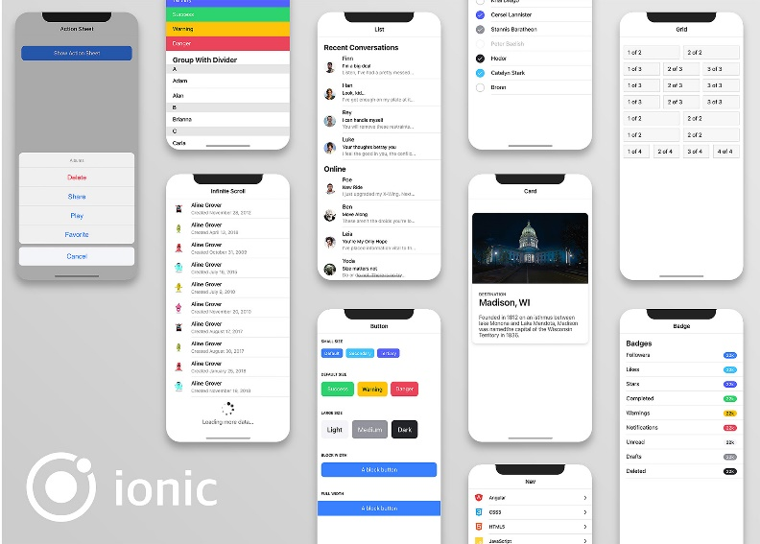

**Figure 1: Ionic**

### Cordova

Cordova Apache is an open source framework for developing mobile devices. Using the native development language for each mobile platform, it allows cross-platform development using popular web technologies like HTML5, CSS3, and JavaScript. Applications run within a platform-specific wrapper that uses standard APIs to access system sensors, data, and network status. Cordova is a platform for developing mobile applications, for a variety of platforms by embedding the browser inside the app.

In fact, an app is a small browser that only displays one website: your app. To speed up the download, all resources can be stored in the application's delivery package, and you can download from the server if appropriate. On the mobile device by default, Cordova only offers the most basic browser features; however, you can expand the number of functions available in the browser by using plugins. Each plugin has a single user interface that can be accessed from any computer using a browser. Cordova is used in my system to implement various plugins on various Android/IOS devices.

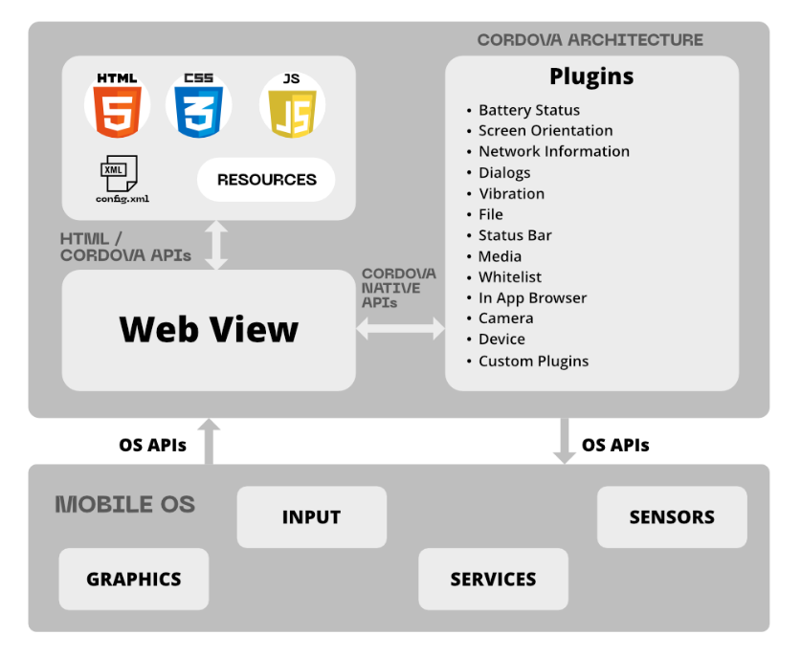

**Figure 2: Cordova** (Anne, et al., 2021)

### Angular

Angular is a Google platform for developing client software. Its first goal is to build single-page applications using SPA solutions. AngularJS is the successor to another AngularJS project in this regard. Angular, on the other hand, is not a modified version of AngularJS, but a completely new system. Two-way binding, for example, in Angular 10 allows you to dynamically modify data in one room, such as models, routing, and so on. The fact that Angular uses Typescript as its programming language is one of its most notable features. However, Typescript is not the only choice. You can write Corner applications in languages like Dart or ***JavaScript*** if you want. However, Angular continues to use Typescript as its primary programming language. The components are one of most important aspects of the application. The part is in charge of how the presentation is shown on the screen.

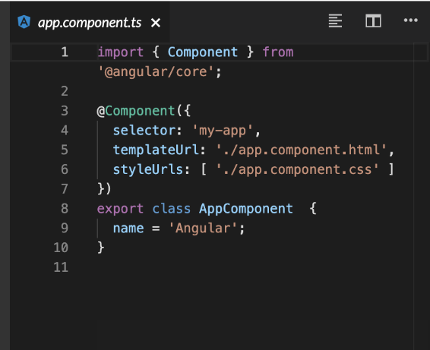

**Figure 3: Angular Component Example** (Guy, et al., 2021)

The term "export key" refers to a class that can be used in other modules. In the same class, only one variable is specified, and it stores a string as a value. To designate a class as a component, use the @Component decorator. If the @Component decorator were not added to the AppComponent class, it would not be considered a component. @Component is a decorator that takes an object and configures it to describe the framework, how to communicate with it, and how to interpret it as an argument.

## Logic

### NodeJS



**Figure 4: Node JS** (Alessandro, et al., 2021)

NodeJS is a server-side platform based on the JavaScript Engine in Google Chrome. Ryan Dahl created NodeJS in 2009, and most recent version is 16.0.0. NodeJS is a framework for creating debauched and ascendable network applications based on JavaScript run-time. NodeJS involves event-driven, non-blocking and the I/O model that makes it lightweight yet effective, making it idyllic for data-intensive real-time program that run across numerous devices, as well as for our application.

### npm



**Figure 5: npm**

The package manager included with NodeJS is called NodeJS Package Manager. Rather than downloading each library separately, we can now use a single command to install all at once. **npm install -** When you run the command the package.json file is searched for in the current folder by npm If a library from the list is found, it will be installed.

## Data Section

The data section displays all of the data that has been saved and allows you to store, view, update, and delete specific items. I only have one database for my application. User details, Google maps, history, images, and other data are all stored in this database.

### Firebase



**Figure 6: Firebase** (Julian, et al., 2021)

“Firebase is a mobile and web app development platform developed by Firebase Inc., which was acquired by Google in 2014”. "Building, developing, and growing your software" is what Firebase is all about. It comes with features “like analytics, databases, messaging, and crash reporting, so you can turn easily and focus on your customers. One of the fastest-growing application development” services is Firebase. Some of the factors are as follows:

1. You do not have to start from scratch when creating a back-end. Firebase is a ready-to-use back-end that includes a database. You just need to include the Firebase SDK in your app and you are ready to go.
2. It is in real time. If you are a developer, you already know how important it is to have a real-time backend/database in today's app industry. When you consider real-time operations, things like chat, news feeds, ratings, and bookings become quite easy.
3. Authentication operations that are simple. Login/register operations are one of the first things that a user-facing program requires. Firebase does this with ease and with very little coding effort.
4. You get many extra features built in, such as push alerts, analytics, and so on.
5. It is free, but there is a limit on how much you can use it.

## Additional

### Google Maps API



**Figure 7: Google Maps** (Francesca, Stabile, Purificato, Giuliano, & Luca, 2021)

With static and dynamic maps, you can create personalized, agile involvements that assures the user have an effective experience when interacting with the page. With high-quality directions and real-time traffic alerts, provide your users with an effective approach to get from point A to point B. To establish more detailed itineraries, determine path the user takes. Places provides users with rich place information for over 100 million localities, allowing them to explore the globe. Allow them to use addresses to locate unique locations.

### Typescript



**Figure 8: Typescript** (Zander, 2021)

Typescript can be compiled in JavaScript and is backwards compatible. In reality, after compilation, any latest browser can run a Typescript application, and it can be used in combination with the NodeJS server platform. The Apache license applies to the code of the compiler that converts Typescript to “JavaScript is a scripting language that allows you to create ability to expressly implement static types, as well as support for classes and connecting modules, as in conventional object-oriented languages. Differentiate Typescript from JavaScript, all of which are intended to speed up development, improve readability, refactoring, and reuse of code, and check for errors during development and compilation.

### HTML



**Figure 9: HTML**

HTML stands for hypertext mark-up language, and it is a programming language for making web pages. HTML is used to generate the web page, and it includes all of the required elements. A link, a table, a numbered or unnumbered list, photos, text divided into paragraphs and sections, and section headings can all be found on a simple HTML page. Define section headings to a simple HTML page. On the HTML tab, you can also use text fields, buttons, select options from a list, check boxes. HTML5 allows you to add video and audio files to a tab, draw on a canvas, and make quick animations with new tags.

### SCSS



**Figure 10: CSS**

Sassy Cascading Style Sheets (SCSS) is a CSS superset. So, first and foremost, I'll define CSS, since it covers a lot of what Sccss does.' CSS actually aid in separating the structure and content of the page “from its appearance. Each code factor defines both the content and the appearance of the page if the page is entirely written in HTML.” Page’s content, but also how it is displayed. For example, not only is there a text “Hello” in this or that location, but it is also highlighted in bold and red. All works a little differently when CSS code is used. Only the order of the page's content elements, as well as their classes, are represented using HTML. In the CSS file, the corresponding classes are written. A set of properties is allocated to each of them. When we assign a class to an HTML element, it inherits all of the properties of that class. The amount of code that has to be repeated is significantly reduced because of this. When a site has many pages, therefore, CSS is needed.

### JavaScript



**Figure 11: JavaScript** (Marius & Johns, 2021)

JavaScript is a scripting or programming language that allows you to implement complicated parts on web pages, if a web page does anything than just sit there and show static details for you to look at, such as showing timely content changes, interactive charts, animated 2D/3D graphics, scrolling video, and so on. JavaScript is almost certainly involved. It is the third layer of a three-layer cake of standard web technologies, the first two of which (HTML and CSS) have been discussed extensively elsewhere in the Learning Field.

## Software and tools used

### Visual Studio Code



**Figure 12: Visual Studio Code** (Ksenia & Cheng, 2021)

Microsoft has made a number of development tools available. However, Visual Studio Code, which runs on Linux, OS X, and Windows, is probably the best thing they have ever published. Without giving up all of the benefits of a full-featured VisualStudio IDE. Microsoft wanted to restructure the programmers' main toolkit, starting with the most significant, the code editor. Although Visual Studio Code is primarily an editor, it also includes integrated development environments (IDEs) that rely on extensions. Visual Studio Code also supports a variety of languages, including JavaScript, Typescript, C sharp, and others. Visual Studio can also be used to develop ASP.NET 5 or NodeJS web projects, as well as communicate with package managers such as npm and debug them. Code fragments, refactoring, navigation, multi-windowing, and git support are just a few of the features accessible. Visual Studio Code is, in some respects, much more convenient than the complete version of Visual Studio and has less hardware specifications.

### GitHub



**Figure 13: GitHub** (Rafael, Sorbo, Canfora, & Panichella, 2021)

GitHub is a project hosting and collaboration platform that allows users to host, upload, and collaborate on projects. It is free to use in Open Source projects. Repositories are GitHub projects that are hosted on the platform. It is here that users can access their projects, download a version of the project to their system, and contribute to the exciting projects. Collaborating on projects, can be difficult because other people's work can intervene with yours and cause problems. To avoid this, GitHub's version control handles this for you by allowing you to undo changes at any time during the project (Rafael, Sorbo, Canfora, & Panichella, 2021).

To split job trees, use branches, and to combine branches together, use merge. For programmers and developers, GitHub is a fantastic social networking site. In addition to being a hosting project. Users may follow each other, subscribe to project notifications, like them, and give them feedback, and so on. These features enable users to keep up to date on projects that they are involved in, as well as communicate with colleagues and employees. These days it is good to have GitHub profile if want to apply for work it acts as portfolio of your work and helps employers to see what your skills are. GitHub is not just for software creation and programming. It is also used in a variety of other programs. Open source guides, documentation programs, educational tools, and other collaborative projects between users. [<https://docs.github.com/en>]

### Microsoft Word



**Figure 14: Microsoft Word** (Mukhedkar, 2021)

It was important to make a choice between LaTeX and Microsoft word to use for writing this dissertation document. Microsoft Word was chosen to complete the project, although I was introduced LaTeX only in first semester in one module and due to busy college schedule, I did not have enough time to get comfortable with it. Where Microsoft word is something have used in years and even though am not expert in word I still have better knowledge on have to use it more sufficient and less time-consuming way. It was much easier to create, edit and read document in word. It has lot of useful features that are very easy to pick up and use it. Newest versions of Microsoft word even has PDF file converter built in its easy as one button click to convert word document into PDF file which was required for final Dissertation document delivery.

[<https://www.techwalla.com/articles/list-of-ms-word-features>]

# Chapter 5: System Design

Developer will go over overall design and architecture of the Application in this section. To demonstrate this researcher has attach code snippets and visual graphs to help you understand the application's architecture. The System Design chapter will be divided into four parts. Firebase Database, Firebase Authentication represent by Data, The NodeJS server represents logic, and Presentation is represented by the Ionic 5 App and Application deployment.

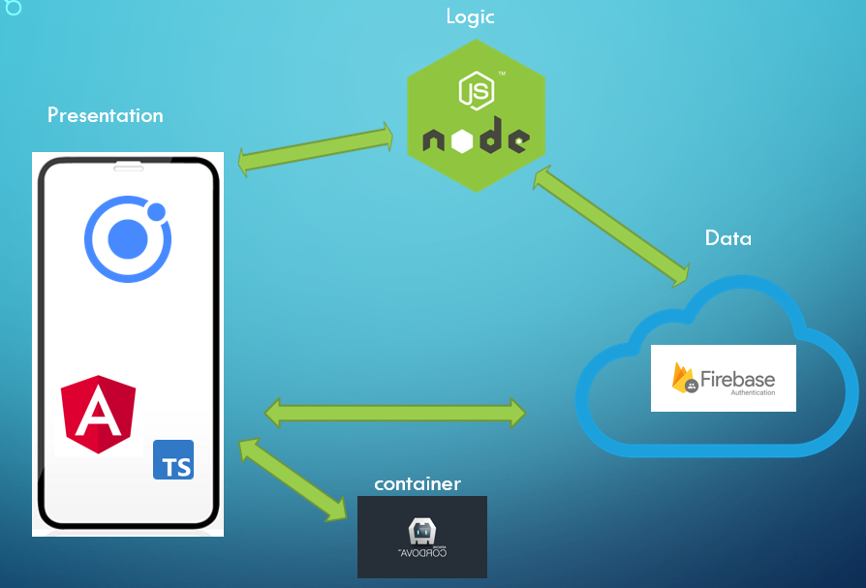

**Figure 15: System Design** (Muminov & Bekmurodov, 2021)

## Data

The data structure represents all of the data that has been processed and allows you to store, view, edit, and delete specific data. For this application, I am using Firebase, which has all the database functions built in, instead of using few different databases, this way it’s much easier to keep track and manage database for application (Muminov & Bekmurodov, 2021).

### Firebase Authentication

Since Firebase is well known in the Ionic community as a popular database for login and registration, researcher chose it to manage user accounts. Since it provided pre-built features including password reset, email, and password authentication. This free Authentication API services appealed to me.

### Firebase real time Database

I chose to use Firebase real time Database to handle database requirements of the application, it provides cloud database to store and sync data from client and server-side development. In my database structure, you can see how user data is stored. There is many resources to follow for ***Firebase*** that made things easier.

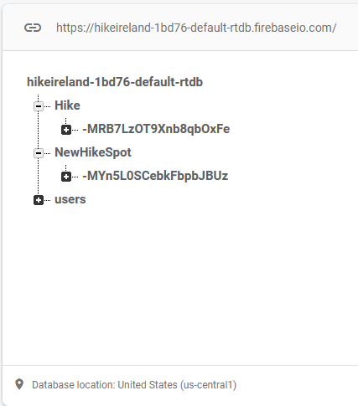

**Figure 16: Database Structure** (Malak, et al., 2021)

### Firestore

As mentioned earlier firebase has many nice features and they are always improving, one of the newest feature is Firestore Database their newest database that is used for mobile app development. The researcher took advantage to learn bit more of this new feature by adding in my application. In Firestore, it was easier to store user data such as images and Google Maps locations history saved by user.

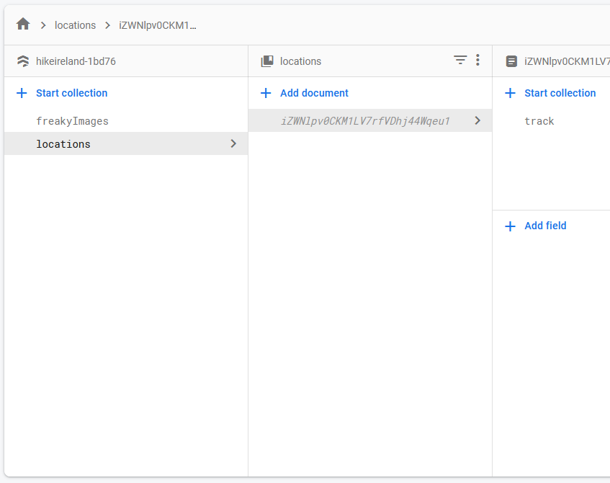

**Figure 17: Firestore** (Dieter, 2021)

## Logic

This program has ability to manipulate application's data in this section. These operations include data generation, storage, upgrading, and deletion. NodeJS is used to manage our business logic. NodeJS was an obvious choice for project architecture because it not only works well with Firebase but also integrates well with Ionic for presentation. NodeJS was more than capable for application due to its lightweight nature and scalability due to its non-blocking I/O calls that enabled tens of thousands of concurrent connections. Because of their similarities, using Javascript for application logic and typescript for providers in the presentation made transitioning between the two a breeze.

### Connection to Data

To set up basic data connection between Firebase and application. The project was later added on firebase however, this could be done on their website. After adding project Firebase configuration keys was issues these keys evoke ionic and firebases consensus.

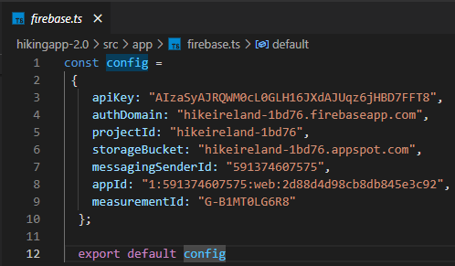

**Figure 18: Connection to Data**

### Routing and accessing data

Next step is to add firebase modules in Application module.

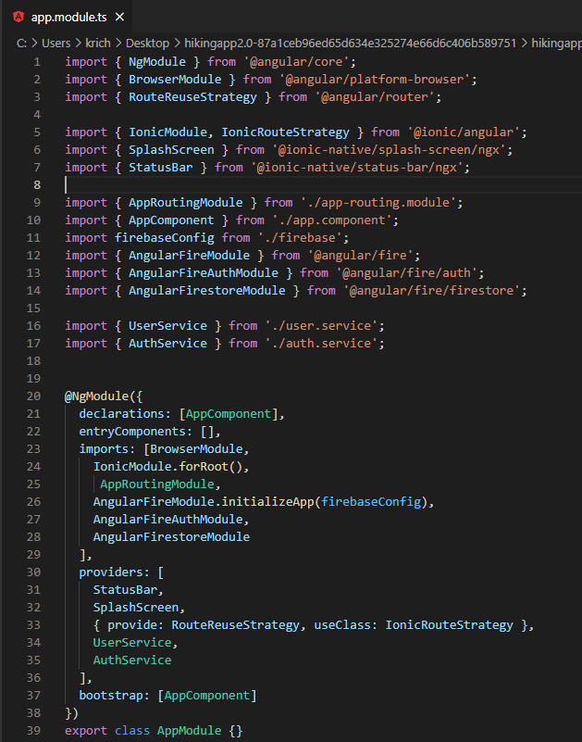

**Figure 19: Routing** (Dhandapani & Palanisamy, 2021)

In this section firebase database is successfully added to application and is ready for further development.

* **User Authentication**

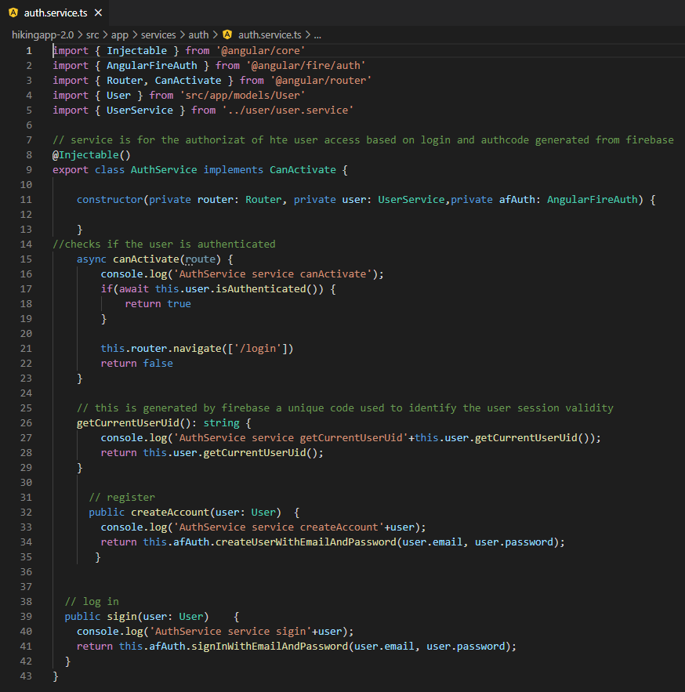

**Figure 20: Auth** (Gunnar, Jöhnk, & Wiecha, 2021)

In here you can see how user authentication is implemented and working with Firebase.

* + - **Create, Update and Delete**

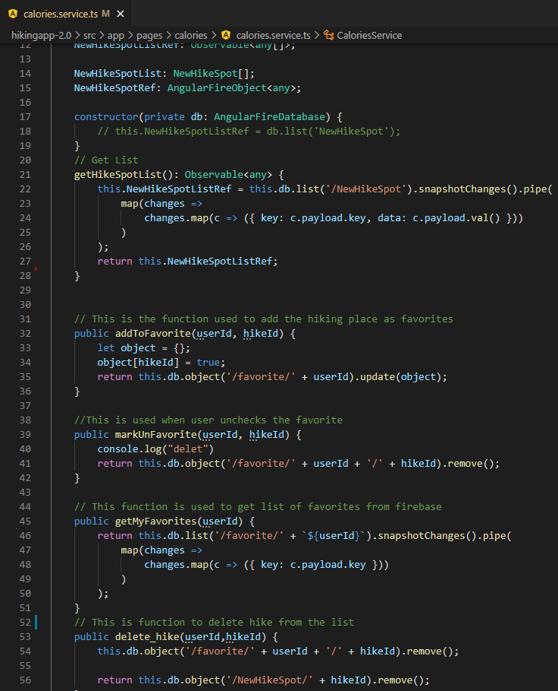

**Figure 21: Create, Update, Delete**

In here, you can see example of how Create, delete and update function is working with Firebase (Marius, 2021).

### Connecting to Presentation

In this stage the developer have a brief look at how we are linking our logic and presentation parts. The application server to run on port 8100 in the logic completed the configured. Our servers can send and receive traffic to our presentation part via this port. The presentation will be able to submit http requests to the server using the IP address, port number, and routing address. The routing address will decide what action the server takes with the info.

## Presentation

I will be looking at five areas in the Presentation Part section. It will into how my Ionic 5 app is designed, how our providers communicate with our NodeJS server and Data databases, a quick tour of each of our Applications pages to demonstrate how they look and work, a quick discussion of Pipes in the app, and finally how I used SCSS to style the application.

### Ionic 5 Application Structure

A brief explanation have to be provided regrading main folders that are in Application folder.

* ***Node-Modules*** – in here we have all the packages that are required to run and develop this application (Deepak, Kagdada, Materny, & Singh, 2021)
* ***src*** – This folder contains most of coding for this application. For example Typescript, Angular, JavaScript, CSS.
  + App – In here, we have main base set up for the application; user will find app components for pages and creating application menus, tabs and structure.
  + Model – in this stage developed has created a model for the user (Ehsan & Mafi, 2021)
  + Pages – this stage have all the application presentation code goes. Here we go through page designs and how they connect to the application
  + Services – In here, application have functions for user, news and covid-19.
  + Assets – In this folder we any images/icons.
* ***WWW*** – In here, you find Cordova plugins that was used for this application, index.html and root component where the application will load.
* 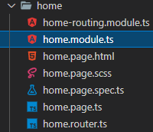***Theme*** – In here, we setup overall design and look for application using GCSS.

## 6 Pages at Application

In Ionic 5 pages are broken down in six parts

* ***Home-routing,module.ts*** - When a user navigates to a URL, routing,module.ts is used to decide which part should be displayed or which module should be loaded.
* ***home.module.ts*** – This serves as way to describe the HomeModule with properties.
* ***home.page.html –*** In here html file creates page layout. Creating buttons, forms and lists.
* ***home.page.scss*** – SCSS page design.
* ***home.page.spec.ts*** - This file is for unit test, this is generated when creating new application, I later found out that you could skip this file by ng new ng-app-name --skip-tests. I did not use unit testing in this project, it would have been great to know how not to include them from the start to avoid extra files.
* ***home.page.ts*** – In here we code functions in bring in imports that needed for functionality.
* ***home.router.ts*** - contains all routings defined during navigation of the application.

### **Login Page**

This will be the first page the user sees when they open the app. They will use an email address and password to log in to their account. Validation is conducted before entering the email and password to ensure that the email is in the correct format, and that the password contains the correct characters and length. In here, Firebase Authentication is used to query the Firebase API to see whether the user exists in our Firebase Database (Venkat, Penumajji, & Neilsen, 2021).



**Figure 22: Login Page**

### Register Page

When a user visits the register page, they will be asked to provide an email address and a password to create an account. The email and password fields are validated in the same way as they are on the login page. When a user clicks 'Register,' the Firebase API saves the user's information and returns a session key, allowing the user to access our app.

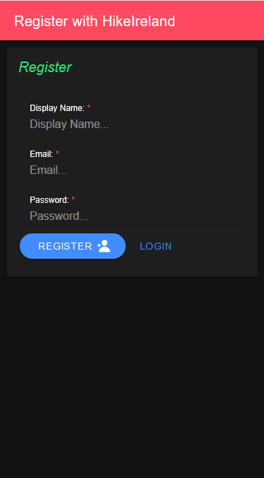

### Menu Bar

The menu bar is accessible ones user is logged in and can navigate freely through the application by using application options.

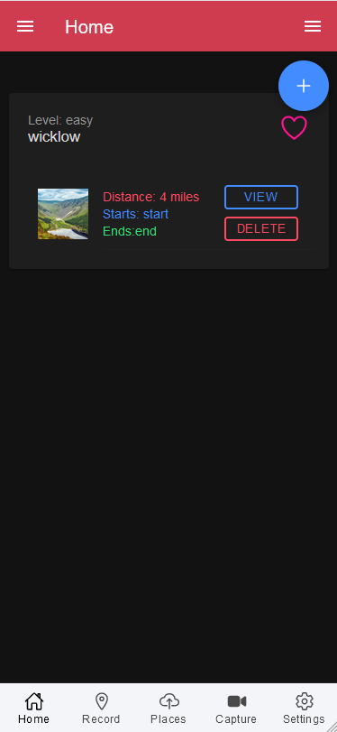

### Home Page

In home page user can add new Hike spot by clicking +, view or update their list, delete and favourite their Hike spot. These functions are not in separate pages for this part I chose to use prompt function where user is directed to form to where user can make alterations.

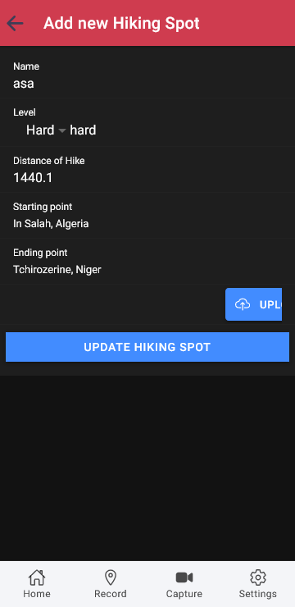 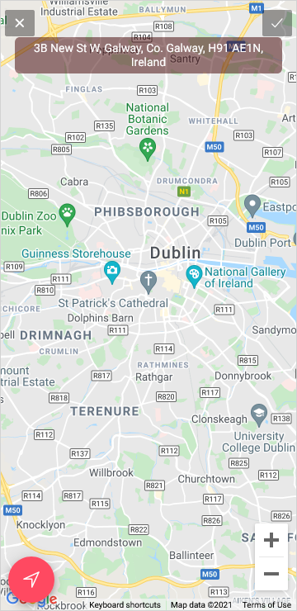

### Record Page

In this page user can save their location, this location will be stored in Firebase database, user will be able to see saved place. The application will display this feature further down.

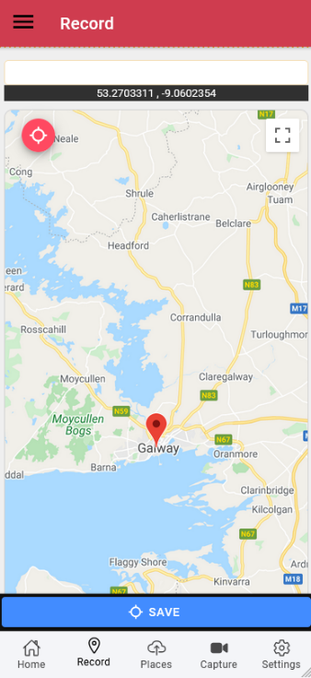

### Places Page

In this page user can select their location and location they want to go to, when user selects both locations marker will present in redline between locations, user also be able to walking distance and time it would take to get to destination.

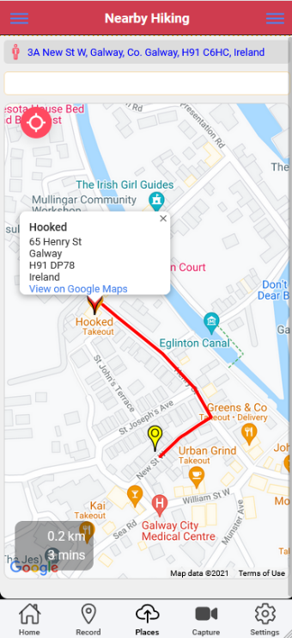

### Capture Page

In this page user will be able to capture media elements and save them in the page.

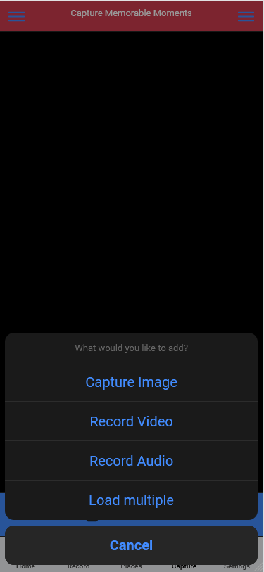

### Setting Page

In this page user can update they login information and log out from application. Again, when clicked on update page this will prompt new page.

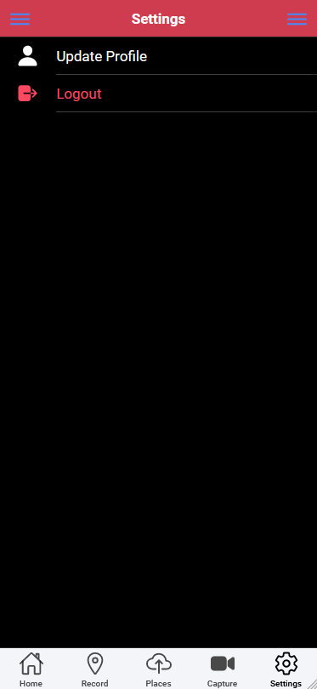 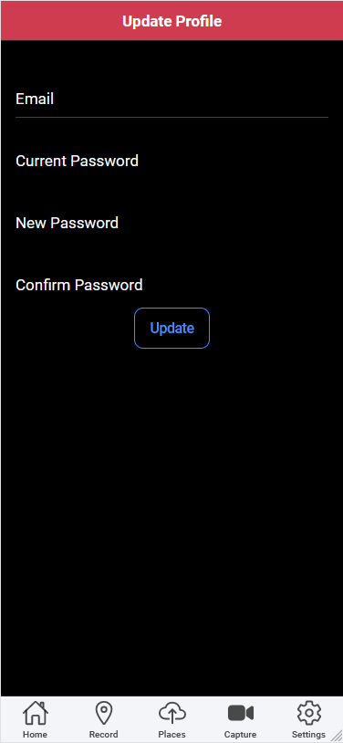

### Personalized Page

Side menu on the left has pages for Upload, Favourites, and Trip history and calorie calculator. Upload, favourite and Trip history is saved in firebase database. When user click to saved history trip map opens o show where saved location was. Calorie calculation was extra feature that was added when user feels in the form amount of calorie will be generated for the user (Hao, 2021).

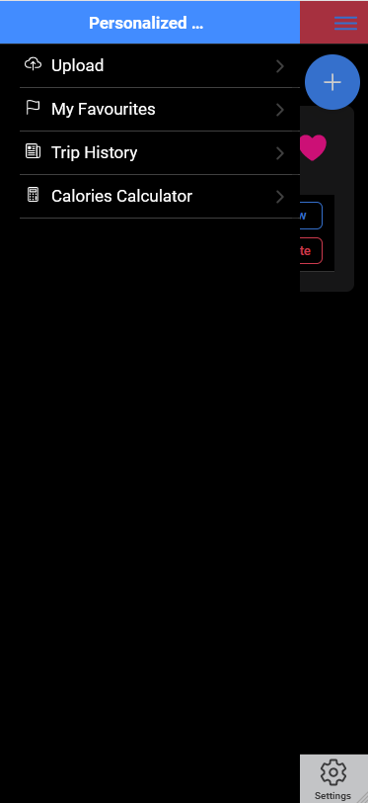 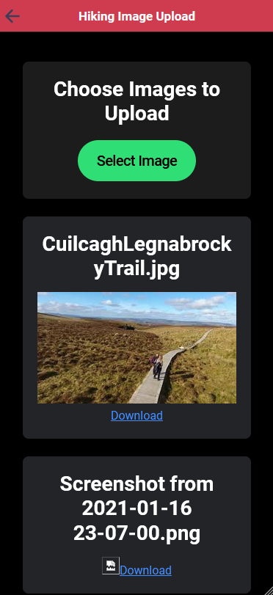 

 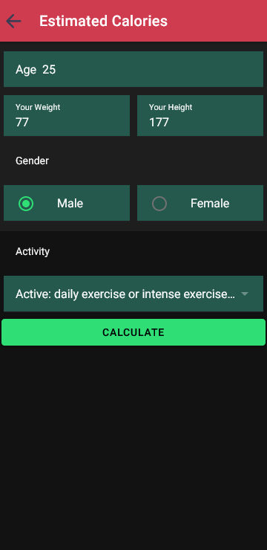

### General Features Page

Side menu on the right represents pages for login, registration for different user to login or new user to register, News page has live news update for user to catch latest news, Covid-19 page showcases Covi-19 cases in Ireland up to date. Home page will bring back to home page and Hike Ireland user’s page is admin feature that will show users that are registered in the application (Nova & Worthey, 2021).

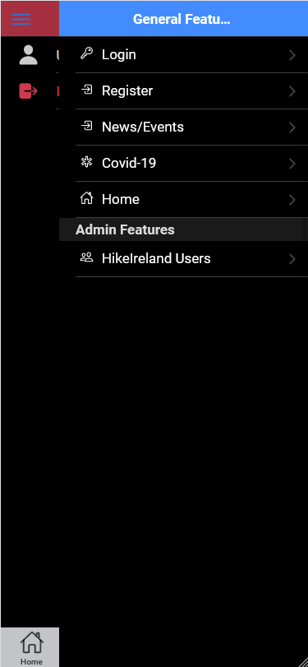 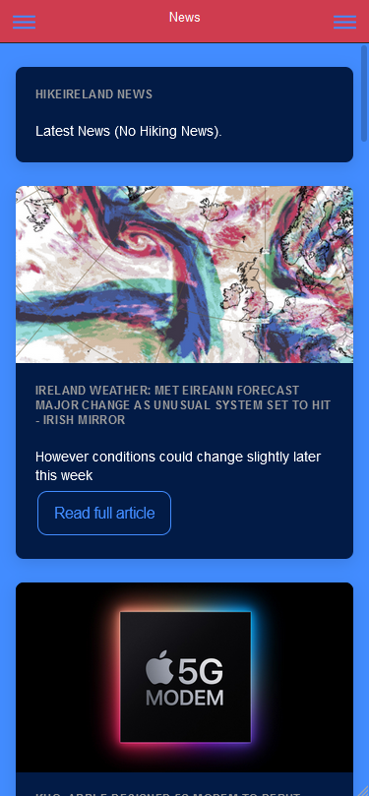 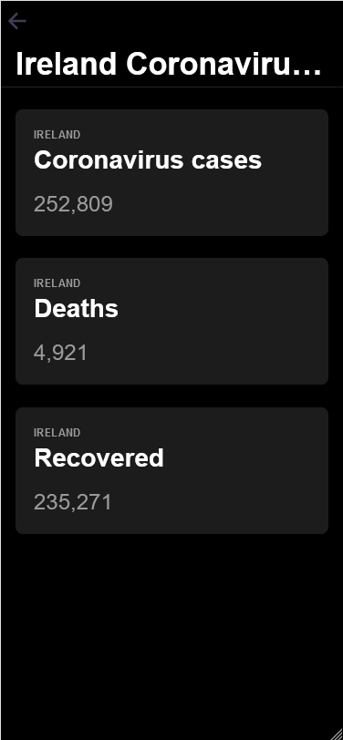

### Deployment and Hosting

In a stage it is decided by developer to host project on my own machine locally, to run application, a Visual Studio Code is used build in command prompt to navigate between folders and execute application deployment.

When I open project folder in Visual studio code I CD into project folder

* C:\Users\krich\Desktop\GMIT 20-21\hikingapp2.0> cd .\hikingapp-2.0\

Moreover, to run application developer simple run

* C:\Users\krich\Desktop\GMIT 20-21\hikingapp2.0\hikingapp-2.0> ionic serve

After all the steps completed correctly application should open in your browser on localhost:8000

# Chapter 6: System Evaluation

In this chapter, researcher evaluate the application in four key areas: Robustness, Testing, Limitations< Result & Objectives.

## 7.1 Robustness

Because of the time constraints, researcher was unable to thoroughly test application for robustness; unfortunately, load testing and stress testing were not possible. For the time being, there was not any errors, bugs, or application failure was experienced when checking my application.

## Testing

Developer believes the Application has met the standards set out at the start of this project through continuous white box testing and routine black box testing. In order to meet these goals, developer conducted testing using white box testing in the following manners – Ionic serve testing and Device testing (Gianini, Speller, Cato, & Stockton, 2021).

## Ionic Serve

Researcher used this method of testing during application development because it allowed me to test application in browser while carrying working, to run application in browser using simple cd to root of the application folder and run the commands:

* ***Ionic Serve***
  + This method of testing was very helpful in the application development because it provided live reload server. What this means is if I made any change in any part of the code, the changes would automatically apply and reload in the browser (David, et al., 2021).
* ***Ionic Serve –Lab***
  + When this command is run application, changes are previewed in iOS, android and windows platforms.

### Device Testing

For iOS testing, I used capacitor plugin to build application for iOS device; this helped to give me idea on how application would run on iOS device. However, in my circumstances, this was not best option for me (Jiska & Hollick, 2021). Instead, I decided to build an Android APK file that I could install on android devise that made testing easier and better for me.

## Limitations

Some of the limitations in the application

### Service Limitations

In this application, I am using Firebase authentication as a free service. Because currently application is only developed as a prototype and plus as a student free price tag is appealing. Application is also hosting locally on my own machine that for this time suits this application as I am are only testing its features and building it as a prototype.

### Testing on Apple device

I had apple device available if I wanted to test iOS version of the application. Nevertheless, as we know apple can be very strict with data laws and some cases you need their OS systems to fully test applications, it can be difficult for windows system users to take full advantage of their development tools. For that reason, I tested iOS version of application using capacitor, this was useful, but I still had some issues some of the time. After doing some research to find better solution I saw that lot of people online had similar issues. That is why testing on android devise was much easier.

## Results & Objectives

When I first started to set objectives for this application at the start of development, I was bit afraid that I wouldn’t have enough time to complete them, but in the end I think I have completed objectives I set out for myself. In regards if application helped any Hike lovers in assisting their needs cannot be conformed as application not yet been lunched on ah app store for people to use as I think this is still working progress. My goal from the start was to make my application easy and simple to use for anyone who does not have that technology know how, as some applications out on the market can be bit doting to use for some people as they are more complex. I believe there can be market for my application once it is on offer to the public.

# Chapter 7: Conclusion

I can honestly say a being individual project it was one of the hardest if not hardest task I have took on in my four years of college, especially with worldwide pandemic happening. Having to learn to live with it, this can be mentally challenging a defiantly put lot more strain on me and my approach to things had to be adjusted to needs of learning from home and doing online classes. The scale and complexity of this project has given me better understanding, knowledge and experience of taking on such big project for the future. With scale of this kind of project had its ups and downs, like all project developers in my position have faced problems and so did I but I tried to stay positive and find solution one task at the time. To be honest after my experience as individual developer on this project, next time I would probably try and work in group project. At the beginning, my main objective was to create an application that will be helpful for people who prefer easy to use application.

List of tasks that have been accomplished:

* User can log into their account
* User can create new account
* When user is logged in user can add data to area they wished to.
* User can delete their data
* User can search destinations on google maps
* User can track their location on google maps
* User can save their location from google maps
* User can see their saved location later on if they wish to
* User can calculate their daily calorie intake.
* User can capture multimedia

Working on Ionic 5, NodeJS and Firebase technologies, I was able showcase my skills gained in my time in GMIT for last four years of studying, and to gain experience and learn new ones that will help me out in the future.

## Future Development

I see myself improving and building this application to its full potential by adding some technical upgrades to rich its full potential and adding business plan.

### App Development

**Get application on the app store** – My aim is to get this application on app store soon as possible. First, I would try to have ***Hike Ireland application*** on android store as its must easier to publish android app. If application gets good feedback than I would consider having application published on Apple store, it is more difficult to publish apps on apple store than Android store.

**Marketplace/Business** – Again depending on success of application I would consider having low cost monthly subscription fee to be added to the application. Add ads in application to get revenue back from ads market.

# References

Alessandro, I., Kumari, P., Tarighi, S., Simonet, N., Popescu, D., Guenther, S., & Hölper, S. (2021). SIRT7-dependent deacetylation of NPM promotes p53 stabilization following UV-induced genotoxic stress. *Proceedings of the National Academy of Sciences 118, no. 5*, 3.

Anne, N., Eyitayo, J., Yang, G., Campbell, C., Sheng, Q., & Ni, J. (2021). An IoT Edge Computing Framework Using Cordova Accessor Host. *IEEE Internet of Things Journal*, 3.

Belén, G.-M. (2019). Hiking tourism in Spain: origins, issues and transformations. *Sustainability 11, no. 13* , 3619.

Benjamin, N., Cattin, P., Ramseyer, R., & Schegg, R. (2020). Improving the Accessibility of Touristic Destinations with an Assistive Technology For Hiking–Applying Universal Design Principles Through Service Design. *In ICCHP*, 193.

Benxia, Z., Mei, Z., Hou, L., & Qiu, S. (2021). Application of Internet of Things and Edge Computing Technology in Sports Tourism Services. *Security and Communication Networks 2021*, 4.

Daniel, R., Hall, N., Costa, J., & Bradford, B. (2021). Alternative environment activities on both sides of the Atlantic: A Canada-Ireland consideration and comparison. *European Physical Education Review*, 83.

David, S., Anderson, G., Paul, L., Seibert, P., Hillesheim, P., Sheng, Y., & Zeller, M. (2021). Design Principles of Lipid-like Ionic Liquids for Gene Delivery. *ACS Applied Bio Materials*, 3.

Deepak, P., Kagdada, H., Materny, A., & Singh, D. (2021). Hybrid structure of ionic liquid and ZnO nano clusters for potential application in dye-sensitized solar cells. *Journal of Molecular Liquids 322*, 114538.

Dhandapani, A., & Palanisamy, C. (2021). DACASN: Dynamic ant routing‐based channel accessing cognitive sensor network in Internet of Things. *International Journal of Communication Systems 34, no. 1*, e4672.

Dieter, M. (2021). 5 Cloud Based Application. *In Modern App Development with Dart and Flutter 2*, 101-116.

Ehsan, K., & Mafi, S. (2021). Ionic liquids: properties, application, and synthesis. *Fine Chemical Engineering*, 22-31.

Fabian, B., & Peters, M. (2020). Soft adventure motivation: an exploratory study of hiking tourism. *Tourism Review* , 23.

Francesca, F., Stabile, R., Purificato, E., Giuliano, R., & Luca, E. (2021). Enriching videos with automatic place recognition in google maps. *Multimedia Tools and Applications*, 1-17.

Gianini, M., Speller, N., Cato, M., & Stockton, A. (2021). An Automated Low-Cost Modular Hardware and Software Platform for Versatile Programmable Microfluidic Device Testing and Development. *Sensors and Actuators B: Chemical*, 38.

Gunnar, A., Jöhnk, J., & Wiecha, D. (2021). A Conceptual Framework for Applying Artificial Intelligence to Project Management. *Journal of Project Management*, 21.

Guy, B., Schwartz, E., Saenko, K., Shahar, O., Feris, R., Giryes, R., & Karlinsky, L. (2021). Fine-grained Angular Contrastive Learning with Coarse Labels. *In Proceedings of the IEEE/CVF Conference on Computer Vision and Pattern Recognition*, 8730-8740.

Hao, W. (2021). Application of Collaborative Filtering Personalized Recommendation Algorithms to Website Navigation. *In Journal of Physics: Conference Series, vol. 1813, no. 1*.

Havatzelet, Y., Cavari, R., & Galilee, E. (2021). National hiking trails: Regularization, statutory planning, and legislation. *Land Use Policy 108*, 86.

Jiska, C., & Hollick, M. (2021). Happy MitM: fun and toys in every bluetooth device. *In Proceedings of the 14th ACM Conference on Security and Privacy in Wireless and Mobile Networks*, 72-77.

Josep, M., Garcia, E., & Celma, D. (2018). Economic and social yield of investing in hiking tourism: the case of Berguedà, Spain. *Journal of Travel & Tourism Marketing 35, no. 2* , 148-161.

Julian, H., Zhang, H., Wei, L., Pascarella, L., Aniche, M., & Shang, W. (2021). Logging Practices with Mobile Analytics: An Empirical Study on Firebase. *arXiv preprint arXiv:2104.02513* , 3.

Ksenia, P., & Cheng, X. (2021). CSRF Protection in JavaScript Frameworks and the Security of JavaScript Applications. *High-Confidence Computing*, 100035.

Malak, P., Amstrong, A., Grigolava, M., Chubinidze, M., Alimbarashvili, E., Vishnepolsky, B., . . . Tartakovsky, M. (2021). DBAASP v3: Database of antimicrobial/cytotoxic activity and structure of peptides as a resource for development of new therapeutics. *Nucleic Acids Research 49, no. D1* , D288-D297.

Marius, M., & Johns, M. (2021). U Can’t Debug This: Detecting JavaScript Anti-Debugging Techniques in the Wild. *In 30th {USENIX} Security Symposium*, 2935-2950.

Marius, S. (2021). Trusted Enforcement of Application-specific Security Policies. *arXiv preprint arXiv:2105.01970*, 34.

Mukhedkar, M. (2021). Reference Management Using MS-Word Software: A Practical Approach. *Technology 3, no. 4*, 223-231.

Muminov, B., & Bekmurodov, B. (2021). Software Database Design and Management Method. *International Journal of Human Computing Studies 3, no. 2*, 320-322.

Ngoc, N. (2021). Co-designing a mobile application for sustainable mobility in smart city. *A gamified resolution to gain the commitment of users*, 5.

Nova, P., & Worthey, G. (2021). Identifying Creative Content at the Page Level in the HathiTrust Digital Library Using Machine Learning Methods on Text and Image Features. *In International Conference on Information*, 478-489.

Rafael, K., Sorbo, A., Canfora, G., & Panichella, S. (2021). Predicting issue types on GitHub. *Science of Computer Programming 205*, 98.

Venkat, M., Penumajji, N., & Neilsen, M. (2021). PiBase: An IoT-based Security System using Raspberry Pi and Google Firebase. *arXiv preprint arXiv:2107.14325*, 54.

Yijie, C. (2021). Research on The Production of Social Space in National Tourism Community Which Depends on Computer Technology. *In Journal of Physics: Conference Series, vol. 1744, no. 4*, 34.

Zander, B. (2021). Chapter Three. The Remainder in the Middle. *In Magnum Opus, pp. 67-89*, 4.

# Important Links

[1] “Cordova” - <https://cordova.apache.org/>

[2] “Angulat” - <https://angular.io/docs>

[3] “NodeJS” - <https://nodejs.org/en/about/>

[4] “npm” - <https://www.npmjs.com/about>

[5] “Firebase” - <https://enappd.com/blog/firebase-with-ionic-4-hosting-auth-and-db-connection/58/>

[6] “Google Maps API” - <https://developers.google.com/maps/documentation>

[7] “TypeScript” - <https://en.wikipedia.org/wiki/TypeScript>

[8] “SCSS” - <https://skillcrush.com/blog/css/>

[9] “HTML” - <https://developer.mozilla.org/enUS/docs/Learn/Getting_started_with_the_web/HTML_basics>

[10] “JavaScript” - <https://developer.mozilla.org/enUS/docs/Learn/Getting_started_with_the_web/JavaScript_basics>

[11] “Ionic 5” - <https://ionicframework.com/blog/announcing-ionic-5/>

[12] “Project structure” - <https://ionicframework.com/docs/v3/intro/tutorial/project-structure/>

[13] “Chrome” - <https://www.readkong.com/page/porting-mobile-ios-app-to-android-klimb-as-6132143>

[14] “Angular routing” - <https://angular.io/tutorial/toh-pt5>

[15] “ionic deployment” - <https://ionicframework.com/docs/v3/intro/deploying/>

[16] “GitHub Project Link” - <https://github.com/ika25/hikingapp2.0>

# Chapter 8: Appendix

## Project Source Code Link:

<https://github.com/ika25/hikingapp2.0>